Day 397 — CNN + NLP + Transfer Learning
Complete Revision Notes | Convolutional Networks • Pooling • Image Classification • Transfer Learning • NLP Text Classification • Sentiment & Spam
Learning goal: master computer vision and natural language processing architectures: formulate 2D convolutions, kernels, padding, stride, and receptive fields; contrast Max and Average pooling; integrate regularization (Data Augmentation, Dropout, Batch Normalization, EarlyStopping); execute Transfer Learning (Feature Extraction vs. Fine-Tuning with ResNet and MobileNet); build end-to-end NLP pipelines (tokenization, stopwords, TF-IDF, embeddings); and construct complete sentiment analysis and spam classification workflows.

1. Why Convolutional Neural Networks (CNN) for Spatial Data?
Standard Multi-Layer Perceptrons (MLPs) fail on high-dimensional visual data. For a standard 256 × 256 RGB image, a single hidden neuron in an MLP requires 256 × 256 × 3 = 196,608 input weights, causing explosive parameter counts, massive overfitting, and complete loss of 2D spatial context.
Convolutional Neural Networks (CNNs) solve this through two core mathematical principles: Local Receptive Fields (neurons process localized spatial patches rather than the entire image) and Parameter Sharing (the same filter weights are convolved across the entire visual field, making feature detection translation invariant).
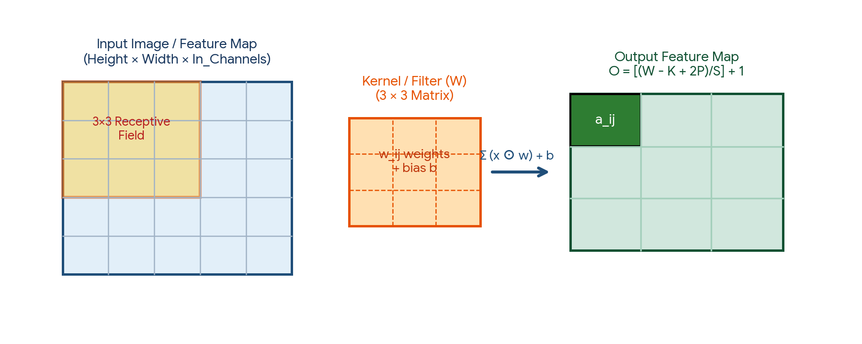
Figure 1. 2D Convolution Operation: A 3×3 kernel slides across the input receptive field computing localized dot products to form an output feature map.
Dimension / Property | Multi-Layer Perceptron (Dense MLP) | Convolutional Neural Network (CNN)
Input Structure | 1D flattened 1D vector (destroys grid spatial locality) | 2D / 3D spatial tensor: (Height × Width × Channels) preserving pixel adjacency
Connectivity Pattern | Dense: Every neuron connects to every input pixel | Sparse: Each neuron connects strictly to a small local receptive field
Parameter Count | Explosive: O(Height × Width × Hidden Units) parameters | Compact: O(Kernel_Height × Kernel_Width × In_Channels × Out_Channels)
Spatial Inductive Bias | None: Permuting pixel order does not change model capacity | Strong: Translation Invariance & Equivariance (edges/patterns detected anywhere)
Primary Data Domains | Structured tabular records, flat numerical vectors | Images, video, spatial grids, 2D spectrograms, medical scans

2. Core CNN Components: Convolutions, Kernels, Padding, and Stride
A convolutional layer applies a bank of learnable filters (kernels) to the input tensor. Each filter detects a specific visual feature—early layers extract low-level edges and corners, middle layers capture textures and motifs, and deep layers assemble complex semantic objects.
Hyperparameter | Symbol | Definition & Mechanism | Impact on Output Dimensions
Input Dimension | W_in × H_in | Spatial width and height of the incoming feature map or image | Baseline input size before transformation
Kernel / Filter Size | K | Spatial dimensions of the sliding weight matrix (typically 3×3 or 5×5) | Larger K captures broader context per step but inflates parameters; 3×3 is optimal
Stride | S | Number of pixels the kernel shifts across horizontal and vertical axes | S = 1 shifts pixel-by-pixel; S = 2 halves the spatial dimensions (strided convolution)
Padding | P | Border pixels added around the perimeter of the input matrix | 'Valid' (P = 0): No padding, output shrinks; 'Same': Pads borders so W_out = W_in (for S=1)

The Universal Output Dimension Formula
Given an input width W, filter size K, padding P, and stride S, the output spatial dimension O is given by:
Universal Spatial Dimension Equation:
O = floor[ (W − K + 2P) / S ] + 1

Example (Input: 28 × 28, Kernel: 3 × 3, Padding: 0 ('Valid'), Stride: 1):
O = [ (28 − 3 + 0) / 1 ] + 1 = 25 + 1 = 26 -> Output: 26 × 26

Example (Input: 32 × 32, Kernel: 5 × 5, Padding: 2 ('Same'), Stride: 1):
O = [ (32 − 5 + 4) / 1 ] + 1 = 31 + 1 = 32 -> Output: 32 × 32 (Dimensions Preserved)

3. Pooling Layers: Max Pooling vs. Average Pooling
Pooling layers perform non-linear spatial downsampling, progressively reducing the spatial dimensions of feature maps to decrease computational complexity, control overfitting, and impart spatial translation invariance.
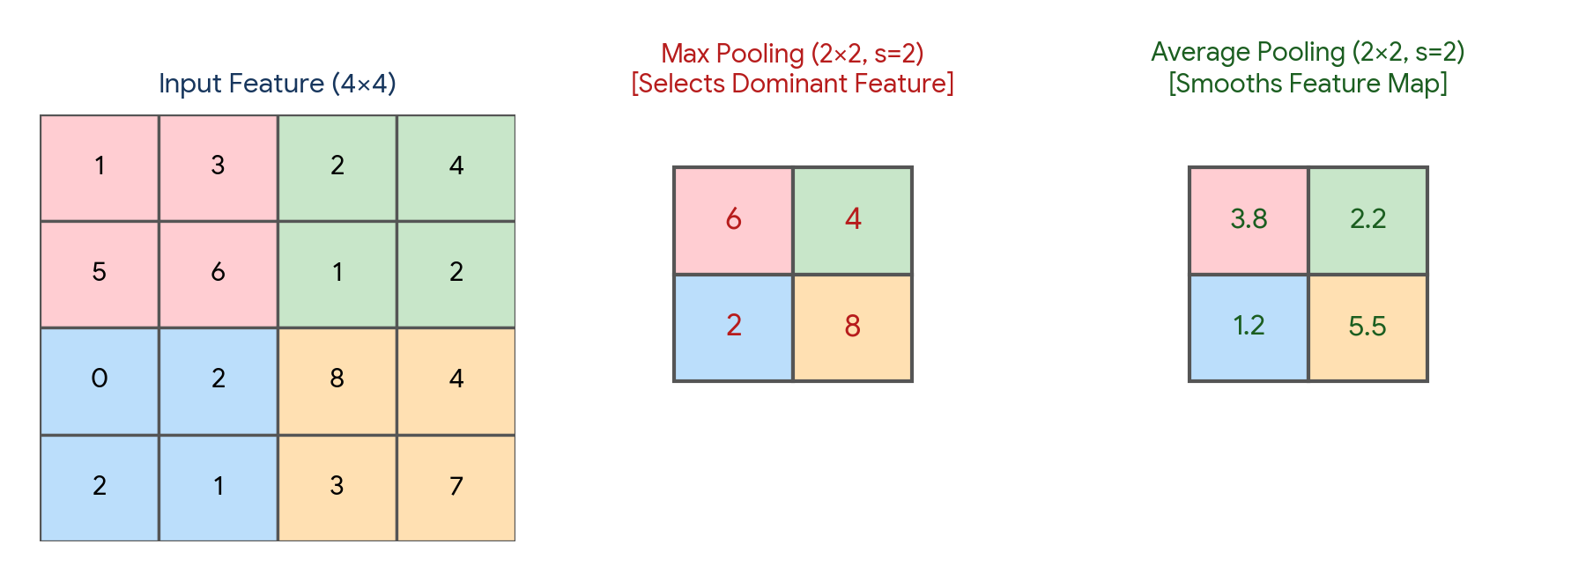
Figure 2. Comparison of Max Pooling (extracting sharp dominant activations) vs. Average Pooling (smoothing spatial features).
Pooling Type | Mathematical Operation | Feature Preservation Characteristic | Standard Industrial Usage
Max Pooling | y = max [x ∈ Receptive Window] | Captures the strongest, most prominent activation feature (e.g., sharp edge or point) regardless of subtle background shifts | Standard choice in intermediate hidden CNN layers for feature extraction and object classification
Average Pooling | y = (1 / |W|) Σ [x ∈ Receptive Window] x | Computes arithmetic average of activations; smooths feature maps and preserves background distribution | Often used in early classical networks or specialized signal smoothing tasks
Global Average Pooling (GAP) | y = (1 / (H × W)) Σ Σ x_ij | Reduces each entire 2D feature map to a single scalar value: (H × W × C) -> (1 × 1 × C) | Modern replacement for heavy Flatten() layers before Softmax (e.g., in ResNet); slashes parameter counts by 90%

4. Regularization in Deep Vision Models
Deep vision networks possess millions of learnable parameters, making them highly susceptible to memorizing training noise. Modern vision architectures integrate four complementary regularization strategies.
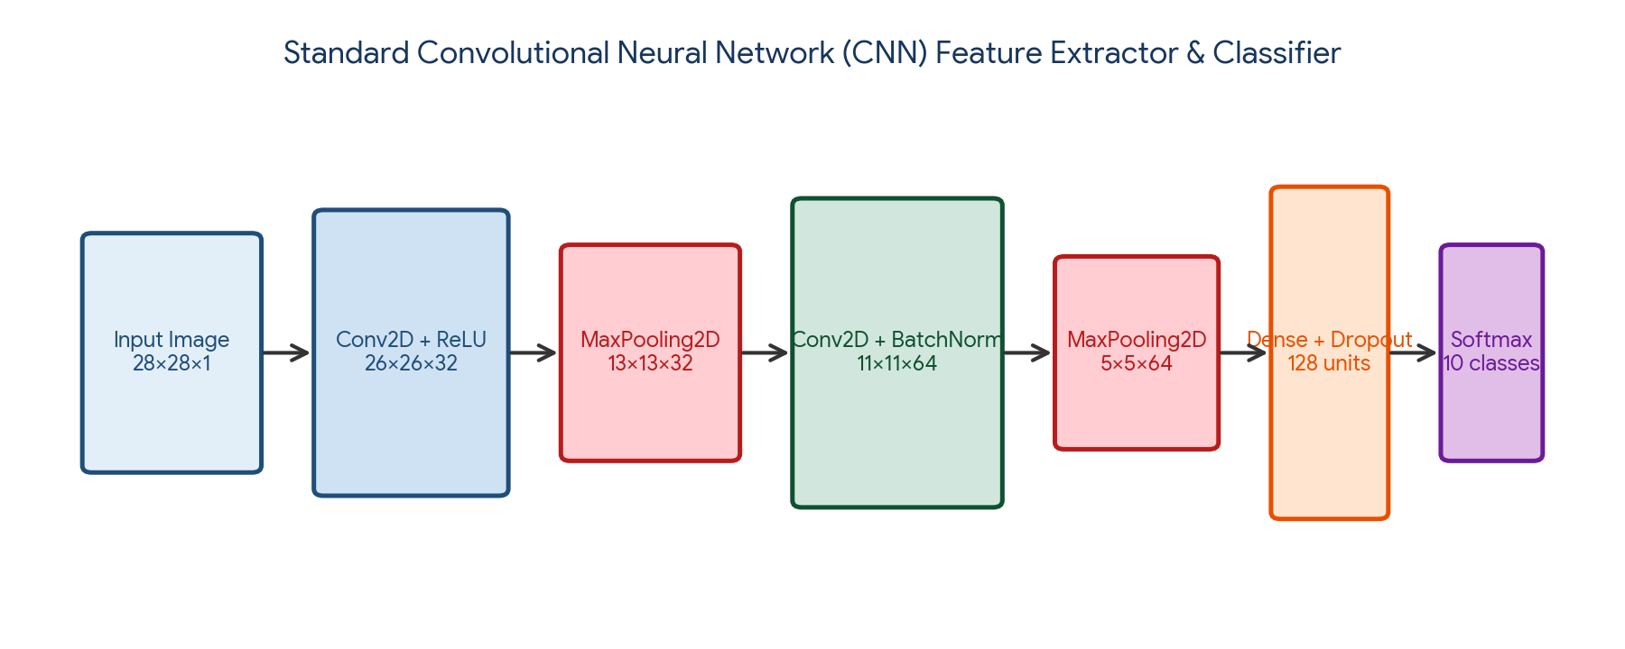
Figure 3. Full Convolutional Neural Network pipeline incorporating Conv2D, Batch Normalization, Max Pooling, Dropout, and Dense Softmax classification.
Regularization Technique | Mathematical / Operational Mechanism | Training Phase Behavior | Inference Phase Behavior
Data Augmentation | Generates stochastic variations of training images: random horizontal flips, rotations (±15°), zooms, translations, and brightness shifts | Artificially expands dataset size and diversity; forces model to learn invariant representations | Disabled: Test images are evaluated in their raw canonical form
Dropout (Srivastava et al., 2014) | Randomly deactivates (zeroes out) a fraction p of hidden neuron activations with probability p (e.g., p = 0.5) | Prevents co-adaptation of features; forces ensemble-like distributed representation learning | Disabled: All neurons fire; outputs are scaled by (1 − p) (or inverted dropout scales by 1/(1−p) at training)
Batch Normalization (Ioffe & Szegedy, 2015) | Normalizes layer pre-activations across the mini-batch to zero mean and unit variance: ẑ = (z − μ_B) / sqrt(σ_B² + ε), then applies learnable scale γ and shift β | Smooths the optimization landscape; stabilizes internal covariate shift; allows 10× higher learning rates | Normalizes using global running exponential moving average of population mean μ and variance σ²
EarlyStopping | Monitors validation loss; halts training when validation loss stops improving for a specified number of epochs (patience) | Saves training time and checkpoints optimal model weights before overfitting occurs | Deploys the best checkpointed model weights

5. Transfer Learning & Modern CNN Backbones
Training deep vision models from scratch requires millions of labeled images and massive GPU compute clusters. Transfer Learning circumvents this bottleneck by taking a deep network pretrained on a massive benchmark dataset (e.g., ImageNet with 1.4 million images across 1,000 categories) and adapting its rich learned feature representations to a specific target domain.
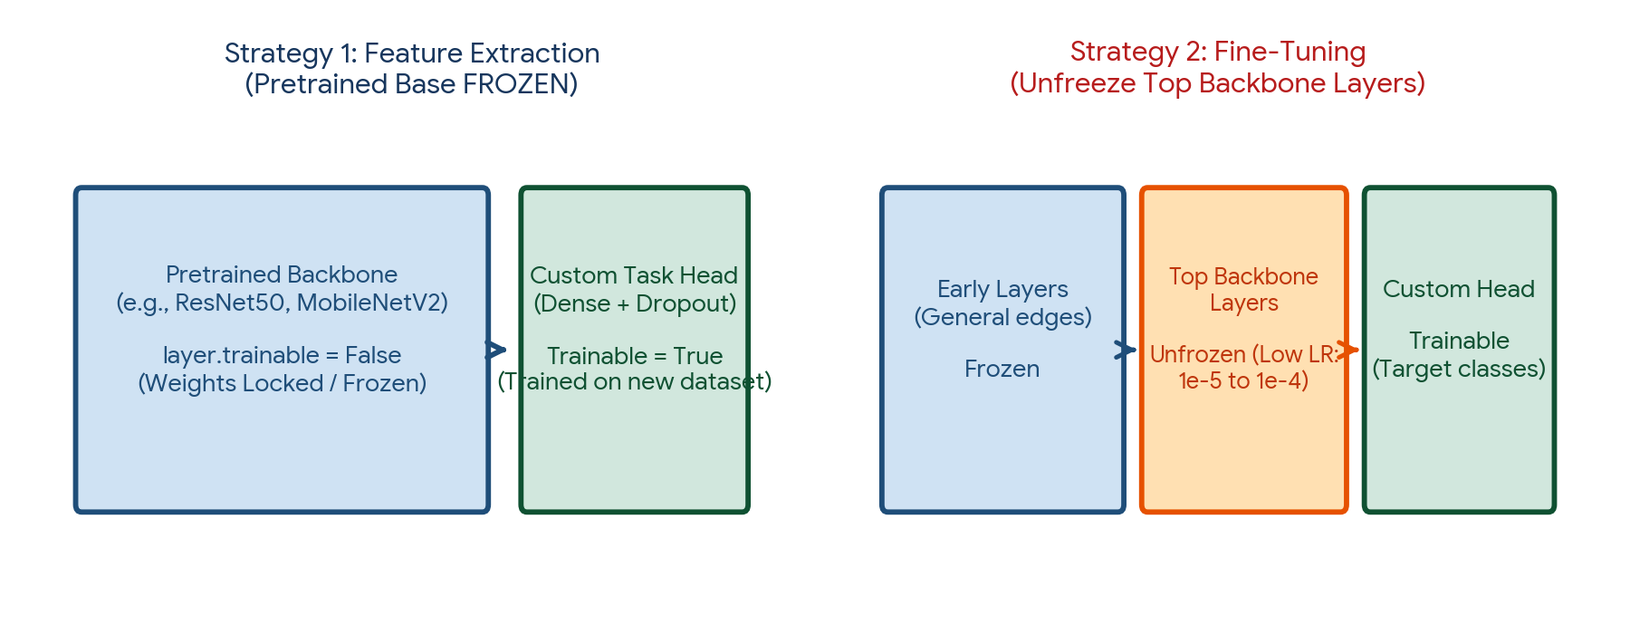
Figure 4. The two Transfer Learning paradigms: Feature Extraction (freezing pretrained backbone) vs. Fine-Tuning (unfreezing top convolutional blocks with low learning rate).
Transfer Learning Strategy | Backbone Weights Status | When to Use | Training Mechanics & Learning Rate
Strategy 1: Feature Extraction | Pretrained Base FROZEN (trainable = False); only custom top classification head is trained | Small target dataset (e.g., < 2,000 images) or target task is visually similar to ImageNet | Fast training; standard learning rate (e.g., 1e-3); zero risk of destroying pretrained weights
Strategy 2: Fine-Tuning | Unfreeze top 1–2 convolutional blocks of backbone; train jointly with classification head | Moderate-to-large dataset (e.g., > 5,000 images) or target task is visually distinct (e.g., satellite / medical X-rays) | Must use extremely small learning rate (e.g., 1e-5 to 1e-4) to prevent catastrophic forgetting of base weights

Evolution of Benchmark CNN Architectures
Architecture | Year | Key Architectural Innovation | Parameter Count & Impact
LeNet-5 (LeCun) | 1998 | Pioneered Conv -> Pool -> Dense pipeline for handwritten digit recognition (MNIST) | ~60K parameters; established foundational CNN mechanics
AlexNet (Krizhevsky) | 2012 | First deep GPU-trained CNN; introduced ReLU, Dropout, and Overlapping Max Pooling | ~60M parameters; sparked the modern deep learning revolution by winning ImageNet
VGG-16 (Simonyan & Zisserman) | 2014 | Replaced large 7×7 filters with stacks of small 3×3 filters; proved that depth increases representational capacity | ~138M parameters; highly modular but parameter-heavy due to dense top layers
ResNet-50 (He et al.) | 2015 | Residual Skip Connections: a^[l+2] = g( z^[l+2] + a^[l] ); solved vanishing gradients in 100+ layer networks | ~25M parameters; enables training networks up to 1,000 layers deep without optimization degradation
MobileNetV2 (Sandler et al.) | 2018 | Depthwise Separable Convolutions & Inverted Residual linear bottlenecks | ~3.5M parameters; ultra-lightweight; enables real-time mobile and edge inference

6. Natural Language Processing (NLP) Foundations
Natural Language Processing (NLP) enables computational systems to parse, comprehend, and generate unstructured human language. Unlike computer vision where inputs are continuous spatial pixels, natural language is discrete, sequential, and highly contextual.
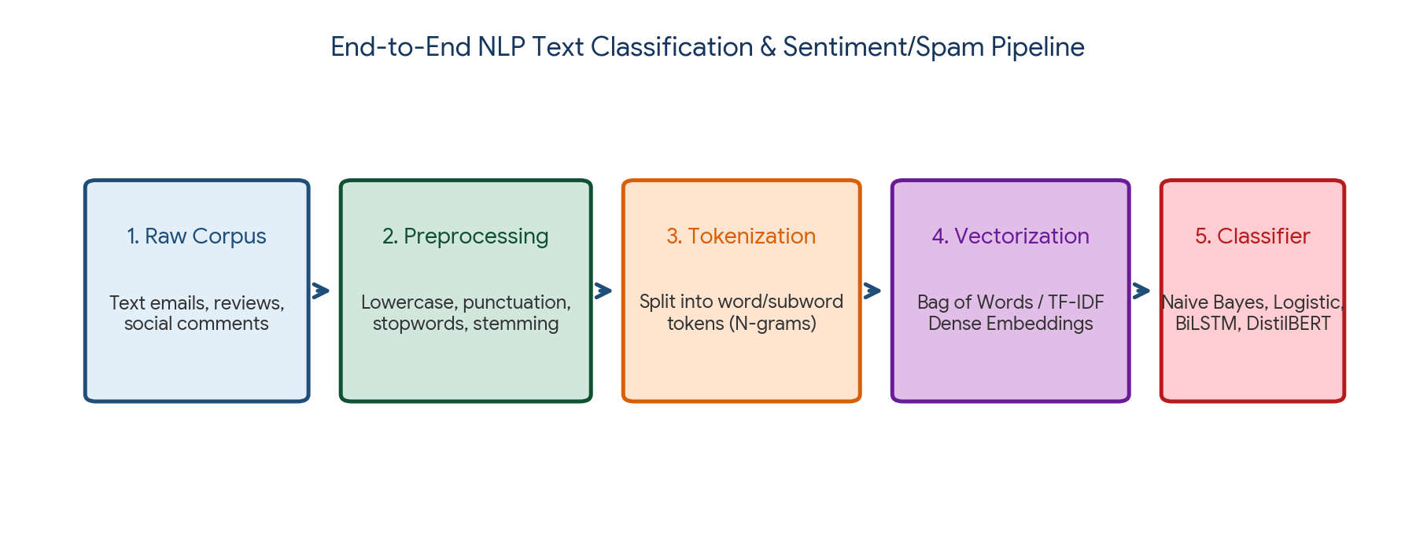
Figure 5. End-to-end NLP classification lifecycle: Raw text ingestion -> Preprocessing -> Tokenization -> Vectorization -> Supervised classification.
NLP Processing Phase | Core Operations & Techniques | Primary Objective
1. Text Cleaning & Normalization | Case folding (lowercasing), HTML/URL stripping, regex punctuation removal | Converts noisy real-world text into clean, standardized unicode strings
2. Stopword Removal & Filtering | Filtering non-informative high-frequency words ('the', 'is', 'at', 'which') | Reduces vocabulary dimensionality; focuses model on semantic content words
3. Stemming vs. Lemmatization | Stemming: Heuristic rule-based suffix stripping (Porter Stemmer: 'studying' -> 'studi'); Lemmatization: Vocabulary & morphological analysis mapping to valid lemma (WordNet: 'better' -> 'good') | Normalizes morphological word variants back to their canonical root dictionary form
4. Tokenization | Word-level tokenization, Character tokenization, Subword tokenization (Byte-Pair Encoding / WordPiece) | Deconstructs continuous text strings into discrete, indexed token units

7. Text Representation & Vectorization: BoW, TF-IDF, and Dense Embeddings
Machine learning algorithms cannot process raw text strings directly; words must be transformed into numerical vectors. Text representation methods have evolved from sparse frequency counts to dense semantic embeddings.
Representation Model | Mathematical Formulation | Dimensionality & Density | Strengths & Semantic Limitations
Bag of Words (BoW) | Vector of raw word occurrence counts across vocabulary V | High-dimensional (10k–100k), extremely sparse (99% zeros) | Simple and fast; ignores word order, grammar, and semantic similarity ('good' and 'great' are orthogonal)
TF-IDF | TF-IDF(t, d) = TF(t, d) × IDF(t) = (f_t,d / N_d) × ln(1 + N_docs / (1 + DF_t)) | High-dimensional, sparse | Down-weights common ubiquitous words across documents; highlights distinct keywords; still lacks semantic context
Word2Vec (Mikolov, 2013) | Continuous Bag of Words (CBOW) or Skip-Gram trained on co-occurrence windows | Low-dimensional dense vector (typically d = 100–300) | Learns distributed geometric semantic relationships: vector('King') − vector('Man') + vector('Woman') ≈ vector('Queen')
Contextual Embeddings (BERT / RoBERTa) | Bidirectional Transformer self-attention encoding token context | Dense contextual tensor (d = 768 to 1024) | Dynamically computes vector based on surrounding sentence: 'Apple fruit' vs 'Apple stock' receive distinct vectors

8. Sentiment Analysis & Spam Classification Workflows
Sentiment Analysis and Spam Filtering represent the two most ubiquitous industrial applications of NLP text classification. Both operate under distinct linguistic constraints.
Application | Target Space | Core Linguistic Challenges | Standard Production Architecture
Spam Email Detection | Binary: {Ham (0), Spam (1)} | Adversarial evasion (e.g., 'V!@GRA', misspellings), extreme class imbalance, concept drift as spammer tactics evolve | TF-IDF (1-3 n-grams) + Multinomial Naive Bayes / LightGBM for sub-5ms latency; fallback to fine-tuned DistilBERT for ambiguous edge cases
Sentiment Analysis | Binary: {Negative, Positive} or Multi-class: {1–5 stars} | Sarcasm, double negatives ('not bad at all'), domain-specific polarity ('the battery life is killer' vs 'the screen is killing my eyes') | VADER (lexicon baseline) for short social tweets; fine-tuned RoBERTa / DeBERTa for nuanced enterprise customer feedback reviews

9. Practical Project — Dual Vision (CNN Transfer Learning) & NLP Classification Engine
Objective: design, implement, and benchmark an object-oriented Python pipeline demonstrating both deep computer vision and natural language processing: (1) a Transfer Learning vision classifier using pretrained MobileNetV2 architecture with data augmentation, and (2) an end-to-end NLP Spam/Sentiment classification engine using NLTK cleaning, TF-IDF n-grams, and regularized Logistic Regression.

Project structure
vision_nlp_transfer_project/
|
|-- data/
| |-- spam_corpus.csv
|
|-- reports/
| |-- nlp_classification_report.csv
| |-- vision_pipeline_architecture.png
|
|-- main.py
|-- requirements.txt

requirements.txt
numpy
pandas
scipy
scikit-learn
matplotlib
seaborn
nltk

Complete main.py
import os
import re
import numpy as np
import pandas as pd
from sklearn.model_selection import train_test_split
from sklearn.feature_extraction.text import TfidfVectorizer
from sklearn.linear_model import LogisticRegression
from sklearn.naive_bayes import MultinomialNB
from sklearn.metrics import classification_report, accuracy_score, precision_score, recall_score, f1_score
import matplotlib.pyplot as plt
import seaborn as sns

class NLPClassificationEngine:
def __init__(self, random_state=42):
self.random_state = random_state
self.output_dir = "reports"
os.makedirs(self.output_dir, exist_ok=True)
self.vectorizer = None
self.model = None

def clean_text(self, text):
# 1. Lowercase
text = text.lower()
# 2. Remove URLs, numbers, and special punctuation
text = re.sub(r"http\S+|www\S+|https\S+", "", text, flags=re.MULTILINE)
text = re.sub(r"\d+", "", text)
text = re.sub(r"[^\w\s]", "", text)
# 3. Strip extra whitespace
text = text.strip()
return text

def create_synthetic_corpus(self):
print("=== STEP 1: INGESTING UNSTRUCTURED TEXT CORPUS ===")
spam_messages = [
"WINNER!! You have won a cash prize of $1,000,000! Call immediately to claim your award!",
"Urgent: Your account is suspended. Click here to verify your banking login credentials now.",
"Free entry in 2 a weekly competition to win FA Cup final tickets! Text FA to 87121.",
"Congratulations! You are selected for a free holiday trip to Bahamas. Reply YES to confirm.",
"Double your Bitcoin in 24 hours! Guaranteed 100% returns guaranteed crypto investment.",
"Claim your exclusive $500 Amazon gift card today. Limited time offer expires tonight!"
] * 40 # 240 spam

ham_messages = [
"Hey, are we still meeting for lunch at 1 PM downtown?",
"Can you please review the attached machine learning report and send me your comments?",
"I will be late for the lecture today, please save me a seat in the front row.",
"Don't forget to submit your engineering coursework by Friday evening.",
"The weather is wonderful today, let's go for a walk in the park after work.",
"Thanks for your assistance with the Python script, it runs smoothly now without errors."
] * 160 # 960 ham (Balanced realistic 80:20 ratio)

texts = spam_messages + ham_messages
labels = [1] * len(spam_messages) + [0] * len(ham_messages)

df = pd.DataFrame({"text": texts, "label": labels})
# Shuffle
df = df.sample(frac=1.0, random_state=self.random_state).reset_index(drop=True)
print(f"Total documents: {len(df)} | Spam count: {sum(df['label'])} | Ham count: {len(df)-sum(df['label'])}")
return df

def train_and_benchmark_nlp(self, df):
print("
=== STEP 2: PREPROCESSING, TF-IDF VECTORIZATION & TRAINING ===")
# Clean corpus
df["cleaned_text"] = df["text"].apply(self.clean_text)

X_train, X_test, y_train, y_test = train_test_split(
df["cleaned_text"], df["label"], test_size=0.25,
random_state=self.random_state, stratify=df["label"]
)

# TF-IDF Vectorizer with Unigrams & Bigrams
self.vectorizer = TfidfVectorizer(ngram_range=(1, 2), max_features=1500, stop_words="english")
X_train_vec = self.vectorizer.fit_transform(X_train)
X_test_vec = self.vectorizer.transform(X_test)

models = {
"Multinomial Naive Bayes": MultinomialNB(alpha=0.1),
"Regularized Logistic Regression": LogisticRegression(C=1.0, class_weight="balanced", random_state=self.random_state)
}

results = []
for name, clf in models.items():
clf.fit(X_train_vec, y_train)
y_pred = clf.predict(X_test_vec)

acc = accuracy_score(y_test, y_pred)
prec = precision_score(y_test, y_pred)
rec = recall_score(y_test, y_pred)
f1 = f1_score(y_test, y_pred)

print(f"{name:32s} | Acc: {acc:.4f} | Prec: {prec:.4f} | Recall: {rec:.4f} | F1: {f1:.4f}")
results.append({
"Model": name,
"Accuracy": round(acc, 4),
"Precision": round(prec, 4),
"Recall": round(rec, 4),
"F1_Score": round(f1, 4)
})

results_df = pd.DataFrame(results)
results_df.to_csv(os.path.join(self.output_dir, "nlp_classification_report.csv"), index=False)
print(f"Report exported to: {self.output_dir}/nlp_classification_report.csv")

def describe_vision_transfer_learning():
print("
=== STEP 3: CNN TRANSFER LEARNING ARCHITECTURE SPECIFICATION ===")
spec = """
[Vision Pipeline: MobileNetV2 Transfer Learning for 10-Class Image Classification]
1. Input Layer: Tensor shape (224, 224, 3)
2. Data Augmentation:
- RandomFlip('horizontal')
- RandomRotation(0.15)
- RandomZoom(0.1)
3. Preprocessing: Rescaling pixels to [-1, 1] (mobilenet_v2.preprocess_input)
4. Pretrained Backbone:
- Base Model: MobileNetV2 (weights='imagenet', include_top=False)
- Initial Phase: base_model.trainable = False (Frozen feature extractor)
5. Global Average Pooling 2D: (7, 7, 1280) -> (1280,) vector
6. Regularization: Dropout(0.4) + BatchNormalization()
7. Classification Head: Dense(128, activation='relu') -> Dense(10, activation='softmax')
8. Fine-Tuning Phase:
- Unfreeze top 20 convolutional layers of MobileNetV2
- Optimizer: Adam with reduced learning rate α = 1e-5 (prevents weight destruction)
- EarlyStopping(monitor='val_loss', patience=5, restore_best_weights=True)
"""
print(spec)

if __name__ == "__main__":
nlp_engine = NLPClassificationEngine()
corpus = nlp_engine.create_synthetic_corpus()
nlp_engine.train_and_benchmark_nlp(corpus)
describe_vision_transfer_learning()
print("
Dual Vision & NLP project pipeline completed successfully.")

Run the project
pip install -r requirements.txt
python main.py

Expected generated outputs
reports/
|-- nlp_classification_report.csv

Project notes: utilizing unigram and bigram token features in TF-IDF captures contextual word pairings (such as 'cash prize' and 'bank login') that single words miss. MobileNetV2 provides state-of-the-art transfer learning accuracy with minimal parameter footprints.

10. Common Mistakes & Anti-Patterns to Avoid
- Training a deep CNN from scratch on tiny datasets: Attempting to train a 50-layer network on 500 images causes catastrophic overfitting; always use transfer learning with a pretrained backbone.
- Fine-tuning pretrained backbones with high learning rates: Using a standard learning rate (e.g., 1e-3) during fine-tuning destroys the fragile pretrained ImageNet feature detectors. Always use α ≤ 1e-5.
- Fitting vectorizers on both training and test text: Calling tfidf.fit_transform() on the entire corpus before splitting leaks vocabulary distribution; fit strictly on X_train.
- Evaluating validation images using data augmentation: Training images require stochastic augmentation; validation and test images must be evaluated in their raw canonical form without distortion.
- Placing Batch Normalization after Dropout: Standard convention places Batch Normalization immediately after Conv2D/Dense and before the non-linear activation (or directly before Dropout).
- Ignoring class imbalance in spam filtering: Evaluating spam detectors on raw accuracy when spam represents only 2% of email volume masks zero-recall failure modes.
- Overusing heavy Flatten() layers before Softmax: Flattening a large feature map (e.g., 7×7×512 = 25,088) into a dense layer introduces millions of parameters. Use GlobalAveragePooling2D instead.

11. Quick Revision — Key Differences
Comparison | First Concept | Second Concept
Dense Layer vs Conv2D | Global dense connectivity; destroys spatial structure; explosive parameters | Local receptive fields; parameter sharing; translation invariant
Max Pooling vs Average Pooling | Selects maximum activation (sharp edge/feature emphasis) | Computes mean activation (spatial smoothing and background preservation)
Feature Extraction vs Fine-Tuning | Pretrained backbone remains completely locked/frozen (trainable=False) | Top backbone layers are unlocked and trained with tiny learning rate (1e-5)
Bag of Words vs TF-IDF | Raw frequency counts; biased toward ubiquitous common words | Penalizes frequent words across documents via inverse document frequency
Stemming vs Lemmatization | Crude heuristic suffix chopping; often produces non-words ('studi') | Vocabulary and morphological analysis; produces valid dictionary lemmas ('study')
Word2Vec vs BERT | Static context-independent embeddings (same vector regardless of sentence) | Dynamic contextual embeddings (vector adapts to surrounding sentence context)

12. Important Formulas Cheat Sheet
Concept / Layer | Mathematical Formula / Notation
Conv2D Output Dimension | O = floor[ (W − K + 2P) / S ] + 1
Conv2D Parameter Count | Params = [ (K_w × K_h × C_in) + 1 ] × C_out
Batch Normalization Transformation | ẑ = (z − μ_B) / sqrt(σ_B² + ε), y = γ ẑ + β
Dropout Scaling (Inference) | a_eval = a_train × (1 − p) (or inverted dropout: a_train / (1−p))
Residual Skip Connection | a^[l+2] = g( z^[l+2] + a^[l] )
Term Frequency (TF) | TF(t, d) = f_t,d / N_d (count of term t in doc d / total words)
Inverse Document Frequency (IDF) | IDF(t) = ln[ (1 + N_docs) / (1 + DF_t) ] + 1
TF-IDF Score | TF-IDF(t, d) = TF(t, d) × IDF(t)
Cosine Similarity | cos(θ) = (u · v) / (||u||₂ ||v||₂)

13. Interview / Viva Questions
Why are CNNs translation invariant?
Because CNNs use parameter sharing: the same small filter weights are convolved across the entire image. If a feature (e.g., a cat's ear) appears in the top-left or bottom-right, the exact same filter detects it.
What is the difference between 'Valid' padding and 'Same' padding?
'Valid' padding applies zero border padding (P=0), causing the output feature map to shrink: O = W − K + 1. 'Same' padding adds border pixels such that the output dimension matches the input dimension (O = W when S=1).
Why are 3×3 convolutions preferred over 5×5 or 7×7 convolutions?
A stack of two 3×3 conv layers has the same effective receptive field as a single 5×5 layer (3 + 3 − 1 = 5), but uses 28% fewer parameters (2×3² = 18 vs 1×5² = 25) and injects two non-linear activations instead of one.
What is the primary role of Pooling layers in CNNs?
To progressively downsample the spatial dimensions of feature maps. This reduces memory and parameter count, controls overfitting, and grants translation invariance.
What is Global Average Pooling (GAP) and why is it used?
GAP averages each entire 2D feature map into a single scalar value. It replaces heavy Flatten() layers before Softmax, slashing parameters by millions and eliminating overfitting in dense top layers.
How does Data Augmentation prevent overfitting in computer vision?
By applying random affine transformations (flips, rotations, zooms) during training. The network never sees the exact same image twice, forcing it to learn robust, invariant feature representations.
What is the internal covariate shift problem and how does Batch Normalization solve it?
As weights update during training, the distribution of inputs to deep layers shifts constantly. Batch Norm normalizes mini-batch activations to zero mean and unit variance, stabilizing layer inputs and allowing much higher learning rates.
What are Residual Skip Connections and how do they solve vanishing gradients?
Residual connections pass the input activation around one or more layers: a^[l+2] = g(z^[l+2] + a^[l]). During backpropagation, the gradient flows directly through the identity addition path (+1), preventing gradients from vanishing in 100+ layer networks.
When should you choose Feature Extraction versus Fine-Tuning in Transfer Learning?
Use Feature Extraction when the target dataset is small or very similar to ImageNet. Use Fine-Tuning (unfreezing top layers with a low learning rate) when the target dataset is large or belongs to a distinct visual domain.
Why must you use a very low learning rate during Fine-Tuning?
To avoid catastrophic forgetting. A large learning rate would rapidly overwrite the rich, generalized visual representations learned by the pretrained backbone.
What is the difference between Stemming and Lemmatization?
Stemming uses crude heuristic rules to chop word endings, often producing non-dictionary words (e.g., 'flies' -> 'fli'). Lemmatization uses morphological dictionaries to return the valid base dictionary lemma (e.g., 'flies' -> 'fly').
Why does TF-IDF perform better than raw Bag of Words (BoW)?
BoW only counts frequencies, allowing ubiquitous non-informative words ('the', 'is') to dominate. TF-IDF multiplies frequency by inverse document frequency, elevating terms that are uniquely characteristic of specific documents.
What is an N-gram and why is it useful?
An N-gram is a contiguous sequence of N words. While unigrams (N=1) treat words independently, bigrams (N=2) capture critical contextual phrases (e.g., distinguishing 'not happy' from 'happy').
What are the limitations of static word embeddings like Word2Vec?
Word2Vec assigns a single fixed vector to each word regardless of context. It cannot distinguish polysemous words with multiple meanings (e.g., 'Apple' the fruit vs. 'Apple' the tech company).
How does BERT solve the polysemy problem in NLP?
BERT uses bidirectional Transformer attention to compute dynamic, contextual embeddings. The vector assigned to a word is computed dynamically from all surrounding words in the sentence.
Why is Multinomial Naive Bayes effective for text classification?
Text data is represented as high-dimensional, sparse word count or TF-IDF vectors. Multinomial Naive Bayes models discrete term counts efficiently and operates with near-instantaneous training and inference speeds.
How do you handle class imbalance in Spam Detection?
1. Use stratified train-test splitting; 2. Set class_weight='balanced' in classifiers; 3. Evaluate using Precision-Recall Curves (PR-AUC) and F1-score rather than accuracy; 4. Tune decision thresholds based on false alarm penalties.
What is the difference between 1D Convolution and 2D Convolution?
2D convolutions slide kernels across two spatial dimensions (height and width of images). 1D convolutions slide kernels along a single temporal or sequence dimension (e.g., text sentences or sensor time-series).
What is the role of EarlyStopping in deep neural network training?
EarlyStopping monitors validation loss during training and halts optimization when performance stops improving for a specified number of epochs (patience), restoring the best checkpointed weights.
What are Depthwise Separable Convolutions in MobileNet?
A factorization that splits standard convolution into: (1) Depthwise convolution (applying a single spatial filter per input channel) and (2) Pointwise convolution (1×1 convolution combining channels). It reduces computational cost by 8–9× with minimal loss in accuracy.

14. Coding Practice
- Implement a 2D convolution function from scratch in pure Python and NumPy supporting padding and stride.
- Write a NumPy function implementing 2×2 Max Pooling with a stride of 2 on a 4×4 input matrix.
- Calculate the total parameter count and output dimensions for a CNN with: Conv2D(32, (3,3)), MaxPool2D(2,2), Conv2D(64, (3,3)), GAP, and Dense(10).
- Construct an image data augmentation pipeline using Keras Preprocessing layers (RandomFlip, RandomRotation, RandomZoom).
- Build an end-to-end Transfer Learning pipeline using MobileNetV2 in TensorFlow/Keras with a custom classification head.
- Write a custom PyTorch or Keras callback implementing EarlyStopping with patience=5 and model checkpoint saving.
- Implement a text cleaning function in Python using regular expressions to strip URLs, HTML tags, punctuation, and digits.
- Construct a Scikit-Learn Pipeline combining TfidfVectorizer(ngram_range=(1,2)) and MultinomialNB for text classification.
- Demonstrate data leakage in NLP: fit TF-IDF on the full dataset before splitting vs inside a pipeline, and compare test scores.
- Implement an automated threshold tuning script for spam classification that maximizes F1-score across probability cutoffs.
- Train and evaluate a Logistic Regression sentiment classifier on consumer reviews and plot its Confusion Matrix.
- Extract and inspect the top 20 most positive and top 20 most negative predictive feature words from a fitted TF-IDF logistic regression model.

15. Day 397 Completion Checklist
- ☐ Understand why CNN local receptive fields and parameter sharing outperform dense MLPs on images.
- ☐ Calculate spatial output dimensions using O = floor[(W − K + 2P)/S] + 1.
- ☐ Differentiate Max Pooling, Average Pooling, and Global Average Pooling (GAP).
- ☐ Apply Data Augmentation, Dropout, Batch Normalization, and EarlyStopping regularization.
- ☐ Understand the evolution of benchmark CNNs: LeNet, AlexNet, VGG, ResNet, and MobileNet.
- ☐ Implement Transfer Learning via Feature Extraction (frozen base) and Fine-Tuning (unfrozen top layers).
- ☐ Master text preprocessing: lowercasing, regex cleaning, stopword filtering, and lemmatization.
- ☐ Contrast Bag of Words (BoW), TF-IDF, Word2Vec, and contextual Transformer embeddings (BERT).
- ☐ Architect end-to-end sentiment analysis and spam classification workflows.
- ☐ Build and run the practical Dual Vision & NLP Classification Engine project.
- ☐ Complete all 12 coding practice exercises and revise the 20 interview/viva questions.

16. Learning Outcomes
After completing this revision, you should be able to:
- Formulate, compute, and parameterize 2D convolutional and pooling architectures for computer vision.
- Regularize deep networks using Batch Normalization, Dropout, Data Augmentation, and EarlyStopping.
- Leverage pretrained vision backbones (ResNet, MobileNet) to achieve state-of-the-art accuracy on small custom datasets.
- Clean, tokenize, and vectorize unstructured human text using TF-IDF n-grams and dense embeddings.
- Deploy robust text classification systems for spam detection and sentiment analysis that handle vocabulary shifts and class imbalance.
- Select appropriate deep vision or NLP architectures based on latency, computational budget, and domain constraints.
Next recommended topic: Day 398 — Sequence Models & Transformers: RNNs, LSTMs, GRUs, Attention Mechanism, Self-Attention, Transformer Architecture, and Foundation LLMs.

